**DA-100**

**Exam A**

**QUESTION 1**

**Note: This question is part of a series of questions that present the same scenario. Each question in the series contains a unique solution that might meet the stated goals. Some question sets might have more than one correct solution, while others might not have a correct solution.**

**After you answer a question in this section, you will NOT be able to return to it. As a result, these questions will not appear in the review screen.**

You have a user named User1. User1 is a member of a security group named Contoso PowerBI. User1 has access to a workspace named Contoso Workspace.

You need to prevent User1 from exporting data from the visualizations in Contoso Workspace. Solution: From the PowerBI setting, you modify the Developer Settings.

Does this meet the goal?

1. Yes
2. No

# Correct Answer: B Section: (none) Explanation

**Explanation/Reference:**

**QUESTION 2**

You plan to embed multiple visualizations in a public website.

Your Power BI infrastructure contains the visualizations configured as shown in the following table.

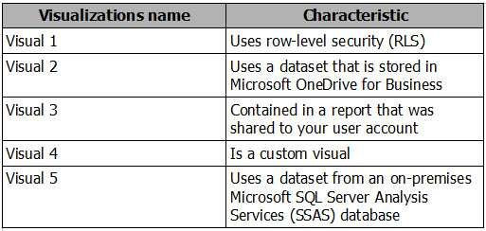

Which two visualizations can you embed into the website? Each correct answer presents a complete solution.

**NOTE:** Each correct selection is worth one point.

1. Visual 1
2. Visual 2
3. Visual 3
4. Visual 4
5. Visual 5

# Correct Answer: BD Section: (none) Explanation

# QUESTION 3

You have a workspace that contains 10 dashboards. A dashboard named Sales Data displays data from two datasets. You discover that users are unable to find data on the dashboard by using natural language queries.

You need to ensure that the users can find data by using natural language queries.

What should you do?

1. From the settings of the workspace, modify the Language Settings.
2. From the Sales Data dashboard, set the dashboard as a Favorite.
3. From the properties of the datasets, modify the Q&A and Cortana settings.
4. From the properties of the dashboard, modify the Q&A settings.

# Correct Answer: C Section: (none) Explanation

# QUESTION 4

DRAG DROP

You have a Microsoft Excel workbook that contains two tables.

From Power BI, you create a dashboard that displays data from the tables. You update the tables each day.

You need to ensure that the visualizations in the dashboard are updated daily.

Which three actions should you perform in sequence? To answer, move the appropriate actions from the list of actions to the answer area and arrange them in the correct order.

**NOTE.** More than one order of answer choices is correct. You will receive credit for any of the correct orders you select.

# Select and Place:

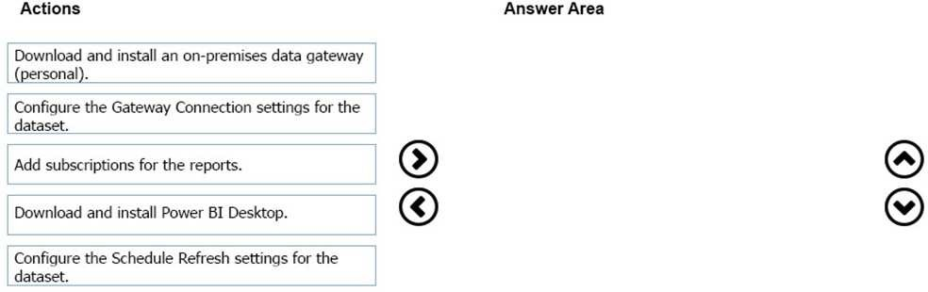

**Correct Answer:**

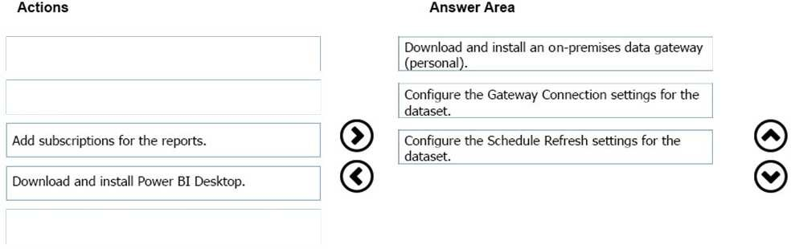

# QUESTION 5

You manage a Power BI model that has two tables named Sales and Product.

You need to ensure that a sales team can view only data that has a CountryRegionName value of Unites States and a ProductCategory value of Clothing. What should you do from Power BI Desktop?

1. Add the following filters to a report. CountryRegionName is United States ProductCategory is Clothing
2. Create a new role that has the following filters. [CountryRegionName] = "United States" [ProductCategory] = "Clothing"
3. Add the following filters in Query Editor. CountryRegionName is United States ProductCategory is Clothing
4. Create a new role that has the following filter. [CountryRegionName] = "United States" && [ProductCategory] = "Clothing"

# Correct Answer: A

# QUESTION 6

You create a report in the Power BI service that displays the following visualizations:

A KPI that displays the count of customers

A table that displays the count of customers by country A line chart that displays the count of customers by year

You need to receive an alert when the total number of customers reaches 10,000. What should you do first?

1. Pin the line chart to a dashboard.
2. Pin the KPI to a dashboard.
3. Embed the report into a Microsoft SharePoint page.
4. Pin the report to a dashboard.

# Correct Answer: D

# QUESTION 7

You have a Power BI dashboard that displays different visualizations of company sales.

You enable Q&A on the dashboard.

You need to provide users with sample questions that they can ask when using Q&A. Which settings should you modify form the Power BI Settings?

1. Subscriptions
2. Workbooks
3. Dashboards
4. Datasets

# Correct Answer: D

# QUESTION 8

You have an app workspace named Retail Store Analysis in the Power BI service.

You need to manage the members that have access to the app workspace using the least amount of administrative effort. What should you do?

1. From the Office 365 Admin center, click **Users**.
2. From the Power BI Admin portal, click **Tenant settings**.
3. From the Power BI Admin portal, click **Usage metrics**.
4. From the Office 365 Admin center, click **Groups**.

# Correct Answer: D

**Section: (none)**

# QUESTION 9

Your organization has a Microsoft Office 365 subscription.

When the users attempt to access the Power BI Service, they receive the error message shown in the exhibit. (Click the **Exhibit** button.)

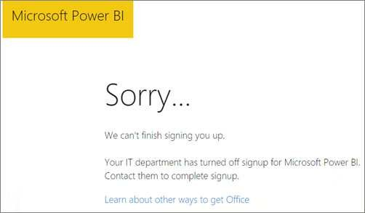

You need to ensure that all the users can access the Power BI service. What should you do first?

1. From the properties of each dashboard, modify the Share dashboard settings.
2. From Microsoft Azure PowerShell, run the Set-MsolDomain cmdlet.
3. Instruct each user to install Microsoft Office 2016.
4. From Microsoft Azure PowerShell, run the Set-MsolCompanySettings cmdlet.

# Correct Answer: D

# QUESTION 10

You have a Microsoft Excel spreadsheet that contains a table named Sales. You need to add the Sales table to a Power BI dashboard as a tile.

How should you configure the tile?

1. From the Power BI service, import the data from the Excel workbook.
2. From Excel, publish the workbook to the Power BI service.
3. From the Power BI tab in Excel, pin the table.
4. From the Power BI service, upload the Excel workbook.

# Correct Answer: C

# QUESTION 11

You are creating a report in Power BI Desktop

You are consuming the following tables.

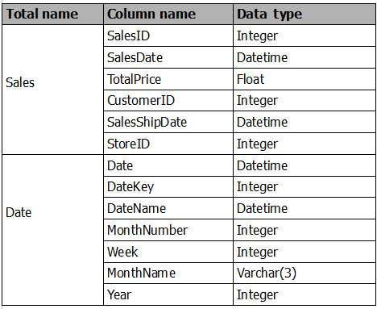

Date[Date] is in the mm/dd/yyyy format. Date[DateKey] is in the ddmmyyyy format. Date[MonthNumber] is in the mm format. Date[MonthName] is in the mmm format.

You create the report shown in the exhibit. (Click the **Exhibit** button.)

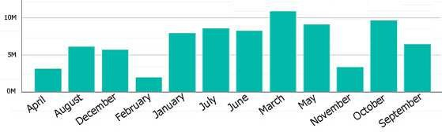

You need to ensure that the months appear in the order of the calendar. How should you sort the MonthName column?

1. by MonthNumber
2. ascending
3. descending
4. by DateKey

# Correct Answer: A

# QUESTION 12

You are creating a report in Power BI Desktop. You are consuming the following tables.

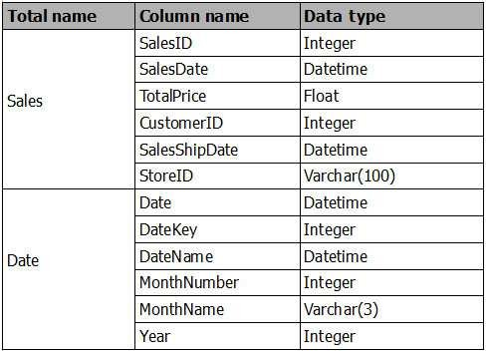

You have a new table named Fiscal that has the same schema as the Date table, but contains the fiscal dates of your company. You need to create a report that displays the total sales by fiscal month and calendar month.

What should you do?

1. Union Fiscal and Date as one table.
2. Add Fiscal to the model and create a one-to-many relationship by using Date[Year] and Fiscal[Year].
3. Add Fiscal to the model and create a one-to-one relationship by using Date[Year] and Fiscal[Year].
4. Merge Fiscal into the Date table.

# Correct Answer: D

# QUESTION 13

You plan to create a Power BI report. You have the schema model shown in the exhibit. (Click the **Exhibit** button.)

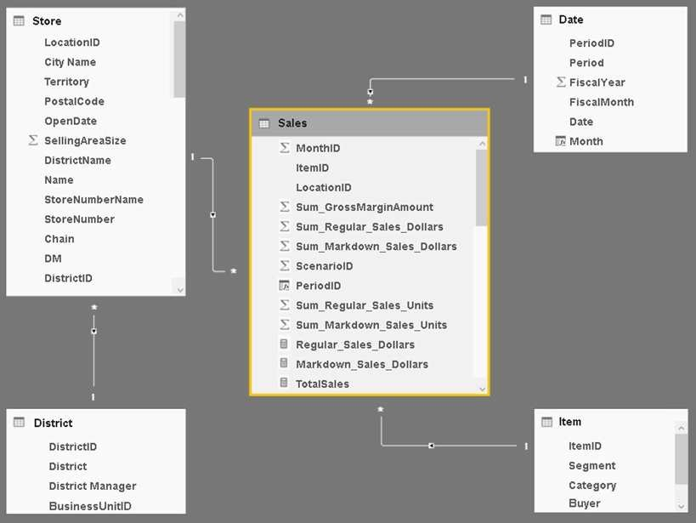

The model has the following relationships:

Store to District based on DistrictID Sales to Store based on LocationID Sales to Date based on PeriodID Sales to Item based on ItemID

You configure row-level security (RLS) so that the district managers of the stores only see the sales from the stores they manage. When the district managers view the Store by Items report, they see items for all the stores.

You need to ensure that the district managers can see items for the stores they manage only. How should you configure the relationship from Sales to Item?

1. Select **Assume Referential Integrity**.
2. Change the Cardinality to **One to Many (1:*)**.
3. Change the Cross filter direction to **Both**.
4. Change the Cardinality to **One to one (1:1)**.

# Correct Answer: C

# QUESTION 14

You use Power BI Desktop to create a visualization for a Microsoft SQL Server data source. You need to ensure that you can use R visualization.

Which two actions should you perform? Each correct answer presents part of the solution.

**NOTE:** Each correct selection is worth one point.

1. Download and install Microsoft R Server.
2. Download and install RStudio Server on the computer that has Power BI Desktop installed.
3. Install SQL Server R Services on the server that runs SQL Server.
4. Enable R Scripting on the computer that has Power BI Desktop installed.
5. Download and install Microsoft R on the computer that has Power BI Desktop installed.

# Correct Answer: E

# QUESTION 15

You have a Power BI model that contains the following two tables:

Sales(Sales_ID, sales_date, sales_amount, CustomerID) Customer(CustomerID, First_name, Last_name)

There is a relationship between Sales and Customer.

You need to create a measure to rank the customers based on their total sales amount. Which DAX formula should you use?

1. RANKX(ALL(Sales), SUMX(RELATEDTABLE(Customer), [Sales_amount]))
2. TOPN(ALL(customer), SUMX(RELATEDTABLE(Sales), [Sales_amount]))
3. RANKX(ALL(customer), SUMX(RELATEDTABLE(Sales), [Sales_amount]))
4. RANK.EQ(Sales[sales_amount], Customer[CustomerID])

# Correct Answer: A

# QUESTION 16

You have a Microsoft SharePoint Online site named Sales.

Your company has 1,000 sales users. All the sales users can access Sales.

You create a report in an app workspace in the Power BI service. You embed the report into a page on the Sales site by using the Power BI web part. You need to ensure that all the sales users can view the report from the Sales site.

What should you do?

1. Configure the Portal Site Connection for the Sales site.
2. Enable anonymous access for the Sales site.
3. Configure the app workspace for Premium capacity.
4. Disable the Embed content in apps setting from the Tenant settings in Power BI.

# Correct Answer: C

# QUESTION 17

You plan to deploy a Power BI app workspace that will be viewed by 10,000 users. You need to ensure that dashboard data can be updated every 30 minutes.

What should you do?

1. Assign each user a Power BI Pro license.
2. Store the dataset in Microsoft Azure Storage that uses the Premium storage tier.
3. Create the app workspace by using an account that is assigned a Power BI Pro license.
4. Configure the app workspace for Premium capacity.

# Correct Answer: D Section: (none) Explanation

# QUESTION 18

You have a Microsoft Excel 2016 workbook that has a Power Pivot model. The model contains the following tables:

Product (Product_id, Product_Name)

Sales (Order_id, Order_Date, Product_id, Salesperson_id, Sales_Amount) Salesperson (Salesperson_id, Salesperson_name, address)

The model has the following relationships:

Sales to Product Sales to Salesperson

You create a new Power BI file and import the Power Pivot model.

You need to ensure that you can generate a report that displays the count of products sold by each salesperson. What should you do before you create the report?

1. Create a one-to-one relationship between Product and Salesperson.
2. For each relationship, change the Cross filter direction to **Both**.
3. For each relationship, change the Cardinality to **One to one (1:1)**.
4. Change a many-to-one relationship between Product and Salesperson.

# Correct Answer: B

# QUESTION 19

You have a Power BI model that contains the following two tables:

Sales (Sales_ID, DateID, sales_amount) Date(DateID, Date, Month, Week, Year)

The tables have a relationship.

You need to create a measure to calculate the sales for same period from the previous year.

Which DAX formula should you use?

1. SUM(sales[sales_amount]) - CALCULATE(SUM(sales[sales_amount]), DATESYID('Date'[Date]))
2. CALCULATE(SUM(sales[sales_amount]), SAMEPERIODLASTYEAR('Date'[Date]))
3. SUM(sales[sales_amount]) – CALCULATE(SUM(sales[sales_amount]), SAMEPERIODLASTYEAR('Date'[Date]))
4. CALCULATEx(SUM(sales(sales_amount]), DATESYID('Date'[Date]))

# Correct Answer: C

# QUESTION 20

You plan to develop a Power BI report that has a bar chart to display the number of customers by location. You have a table named Customer that has the following columns:

CustomerID CustomerName Address

City ProvState Country

You need to allow users to drill down by location. The report will display the number of each customer by Country, and drill down to ProvState, and then to City. How should you configure the drill down in the bar chart?

1. In the Legend field, add Country. In the Axis field, add ProvState at the top, followed by City.
2. In the Value field, add Country at the top, followed by ProvState, and then City.
3. In the Value field, add Country. In the Legend field, add ProvState at the top, followed by City.
4. In the Axis field, add Country at the top, followed by ProvState, and then City.

# Correct Answer: D

# QUESTION 21

You have a table named Sales that contains sales data for the United States. A sample of the data in Sales is shown in the following table.

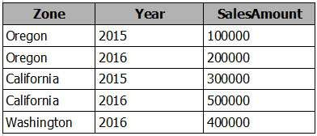

When you attempt to create a map that shows SalesAmount by Zone, you discover that the map shows a bubble based on cities instead of states. You need to ensure that the map shows bubbles based on states.

What should you do?

1. Add a column named Country that contains United States as the value.
2. Add a column for longitude and a column for latitude.
3. Select the Zone field. From the Modeling tab, change the Data Category.
4. Select the Zone field. From the Modeling tab, change the Data Type.

# Correct Answer: C

# QUESTION 22

You have two tables named CustomerVisits and Date in a Power BI model.

You create a measure to calculate the number of customer visits. You use the measure in the report shown in the exhibit. (Click the **Exhibit** button.)

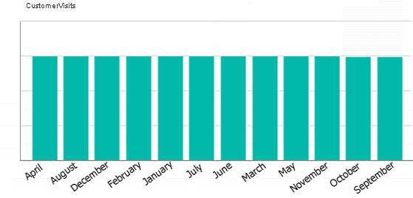

You discover that the total number of customer visits was 60,000, and that there were only 5,000 customer visits in August. You need to fix the report to display the correct data for each month.

What should you do?

1. Modify the measure to use the CALCULATE DAX function.
2. Create a relationship between the CustomerVisits table and the Date table.
3. Modify the measure to use the sum DAX function.
4. Create a hierarchy in the Date table.

# Correct Answer: B

# QUESTION 23

You have the following tables.

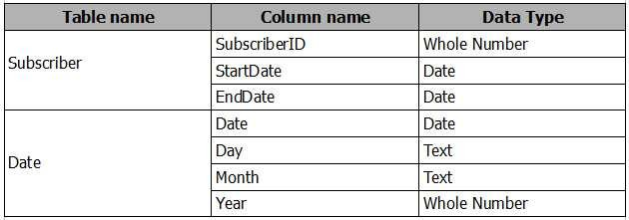

There is a many-to-one relationship from Subscriber to Date that uses Subscriber[StartDate] and Date[Date]. The Cross filter direction of the relationship is set to Single.

You plan to create a column chart that displays the following two measures: Count of SubscriberID by Month based on the StartDate

Count of SubscriberID by Month based on the EndDate What should you do before you create the measures?

1. Create an active one-to-one relationship from Subscriber[StartDate] to Date[Date].
2. Change the Cross filter direction of the active relationship to **Both**.
3. Change the active relationship for many-to-one.
4. Create an inactive many-to-one relationship from Subscriber[StartDate] to Date[Date].

# Correct Answer: B

# QUESTION 24

**Note: This question is part of a series of questions that use the same scenario. For your convenience, the scenario is repeated in each question. Each question presents a different goal and answer choices, but the text of the scenario is exactly the same in each question in this series.**

**Start of repeated scenario.**

You have a Microsoft SQL Server database that has the tables shown in the Database Diagram exhibit. (Click the **Exhibit** button.)

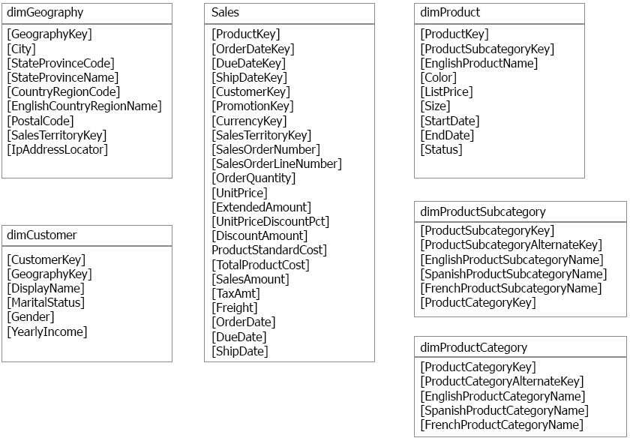

You plan to develop a Power BI model as shown in the Power BI Model exhibit. (Click the **Exhibit** button.)

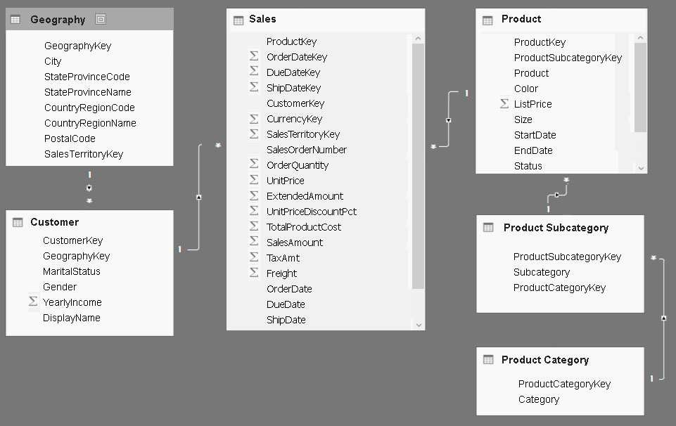

You plan to use Power BI to import data from 2013 to 2015. Product Subcategory[Subcategory] contains NULL values. **End of Repeated Scenario.**

You implement the Power BI model.

You add another table named Territory to the model. A sample of the data is shown in the following table.

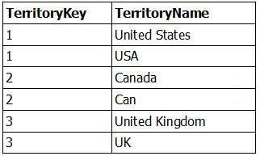

You need to create a relationship between the Territory table and the Sales table.

Which function should you use in the query for Territory before you create the relationship?

1. Table.Distinct
2. Table.IsDistinct
3. Table.ReplaceMatchingRows
4. Table.RemoveMatchingRows

# QUESTION 25

**Note: This question is part of a series of questions that use the same scenario. For your convenience, the scenario is repeated in each question. Each question presents a different goal and answer choices, but the text of the scenario is exactly the same in each question in this series.**

**Start of repeated scenario.**

You have a Microsoft SQL Server database that has the tables shown in the Database Diagram exhibit. (Click the **Exhibit** button.)



You plan to develop a Power BI model as shown in the Power BI Model exhibit. (Click the **Exhibit** button.)



You plan to use Power BI to import data from 2013 to 2015. Product Subcategory[Subcategory] contains NULL values. **End of Repeated Scenario.**

You implement the Power BI model.

You plan to add a table named Date to the model. The table will have columns for the date, year, month, and end of the last month, and will include data from January 1, 2013 to December 31, 2015.

The Date table and the Sales table will have a relationship. Which DAX functions should you use to create the columns?

1. CALENDARAUTO, YEAR, MONTH, and EOMONTH
2. CALENDAR, YEAR, MONTH, and ENDOFMONTH
3. CALENDARAUTO, YEAR, MONTH, and ENDOFMONTH
4. CALENDAR, YEAR, MONTH, and EOMONTH

# Correct Answer: D

# QUESTION 26

From Power BI Desktop, you create a query that imports the following table.

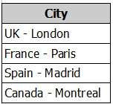

You need to configure the table to appear as shown in the following table:

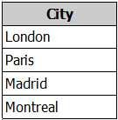

What should you do?

1. From the Format menu, click **Trim**.
2. From the Extract menu, click **Last Characters**.
3. From the Split Column menu, click **By Delimiter**.
4. From the Extract menu, click **Text After Delimiter**.

# Correct Answer: D

# QUESTION 27

You plan to create several datasets by using the Power BI service. You have the files configured as shown in the following table.

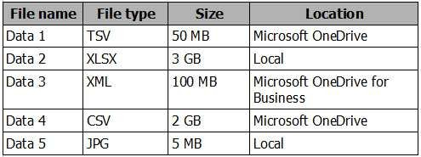

You need to identify which files can be used as datasets.

Which two files should you identify? Each correct answer presents part of the solution.

**NOTE:** Each correct selection is worth one point.

1. Data 1
2. Data 2
3. Data 3
4. Data 4
5. Data 5

# Correct Answer: AE

# QUESTION 28

**Note: This question is part of a series of questions that present the same scenario. Each question in the series contains a unique solution that might meet the stated goals. Some question sets might have more than one correct solution, while others might not have a correct solution.**

**After you answer a question in this section, you will NOT be able to return to it. As a result, these questions will not appear in the review screen.**

You have an app workspace that contains a report. The report contains sensitive data.

You need to ensure that you can embed the report into a custom application that will be accessed by external users. The external users will **NOT** have a Microsoft Azure Active Directory user account or Power BI licenses.

Solution: Configure the app workspace to be read-only for members and to run in a shared capacity. Does this meet the goal?

1. Yes
2. No

# Correct Answer: B

**QUESTION 29**

**Note: This question is part of a series of questions that present the same scenario. Each question in the series contains a unique solution that might meet the stated goals. Some question sets might have more than one correct solution, while others might not have a correct solution.**

**After you answer a question in this section, you will NOT be able to return to it. As a result, these questions will not appear in the review screen.**

You have an app workspace that contains a report. The report contains sensitive data.

You need to ensure that you can embed the report into a custom application that will be accessed by external users. The external users will **NOT** have a Microsoft Azure Active Directory user account or Power BI licenses.

Solution: Purchase Power BI Premium P1, and then configure the app workspace to run in a dedicated capacity. Does this meet the goal?

1. Yes
2. No

# Correct Answer: A

# QUESTION 30

**Note: This question is part of a series of questions that present the same scenario. Each question in the series contains a unique solution that might meet the stated goals. Some question sets might have more than one correct solution, while others might not have a correct solution.**

**After you answer a question in this section, you will NOT be able to return to it. As a result, these questions will not appear in the review screen.**

You have a Microsoft Excel workbook that is saved to Microsoft SharePoint Online. The workbook contains several Power View sheets. You need to recreate the Power View sheets as reports in the Power BI service.

Solution: From Excel, click **Publish to Power BI**, and then click **Export**. Does this meet the goal?

1. Yes
2. No

# Correct Answer: B

**QUESTION 31**

**Note: This question is part of a series of questions that present the same scenario. Each question in the series contains a unique solution that might meet the stated goals. Some question sets might have more than one correct solution, while others might not have a correct solution.**

**After you answer a question in this section, you will NOT be able to return to it. As a result, these questions will not appear in the review screen.**

You have a Microsoft Excel workbook that is saved to Microsoft SharePoint Online. The workbook contains several Power View sheets. You need to recreate the Power View sheets as reports in the Power BI service.

Solution: From the Power BI service, get the data from SharePoint Online, and then click **Import**. Does this meet the goal?

1. Yes
2. No

# Correct Answer: A

# QUESTION 32

Your company has several developers who plan to create custom solutions that will interact with the API for the Power BI service. Which three operations can the developers achieve by using the API? Each correct answer presents a complete solution.

**NOTE**: Each correct selection is worth one point.

1. Retrieve rows from a dataset
2. Create a dataset
3. Add rows to a dataset
4. Refresh an imported dataset
5. Add a member to a row-level security role

# Correct Answer: ABC

**QUESTION 33**

You have the visualization shown in the following exhibit.

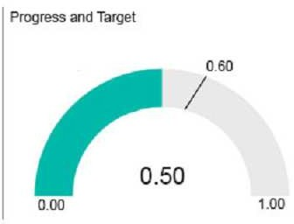

You need to display the values as shown in the following exhibit.

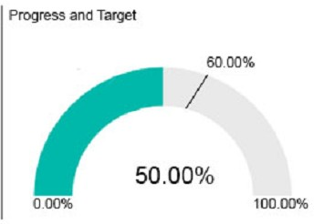

What should you do?

1. Create a calculated column that adds the % symbol to the values.
2. From the Modeling tab, change the Data Type to **Percentage**.
3. Edit the query of the data source and change the Data Type to **Percentage**.
4. Create a measure that adds the % symbol to the values,

# Correct Answer: D

**QUESTION 34**

You have a service published to a website.

When you connect to the website, you receive the following data.

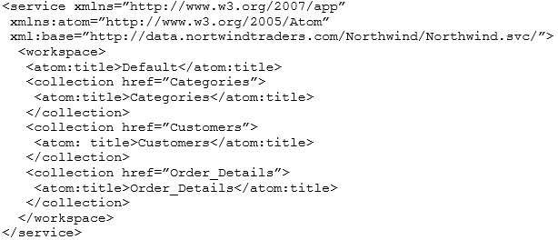

You need to create a query that retrieves the Categories data and the Customers data. Which type of source should you use?

1. JSON
2. Text/CSV
3. OData Feed
4. XML

# Correct Answer: D

**QUESTION 35**

You are importing sales data from a Microsoft Excel file named Sales.xlsx into Power BI Desktop. You need to create a bar chart showing the total sales amount by region.

When you create the bar chart, the regions appear as expected, but the sales amount value displays the count of sales amount instead of the sum of sales amount each region.

You need to modify the query to ensure that the data appears correctly. What should you do?

1. Delete the query, import the data into Microsoft SQL Server, and then import the data from SQL Server.
2. In Query Editor, add a calculated column that totals the sales amount column.
3. Change the Data Type of sales amount column to **Numeric.**
4. Refresh the data model.

# Correct Answer: B

**QUESTION 36**

You create a KPI visualization in Power BI Desktop that uses the month as the trend axis. You discover that the data is not sorted by month.

You need to change the sort order of the visualization. What should you do first?

1. Convert the visualization to a different type.
2. Remove the trend axis from the visualization.
3. Modify the visual level filters.
4. Modify the drill through filters.

# Correct Answer: B

**QUESTION 37**

You have a Microsoft SQL Server Analysis Services (SSAS) cube that contains historical data. In Power BI Desktop, you have the following query for the cube.

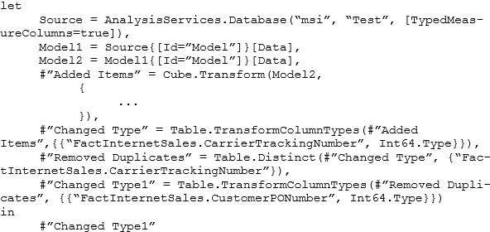

The query retrieves 25,499 records.

When you check the data warehouse that is the source of the cube, you discover that there are 26,423 records. You need to ensure that the query retrieves all 26,423 records.

What should you do?

1. From Query Editor, refresh all the data.
2. Change the query to use Live connection mode.
3. Delete the Remove Duplicates step.
4. Add an Unpivot Columns step.

# Correct Answer: C

**QUESTION 38**

You have a query that retrieves sales data. A sample of the data is shown in the following table.

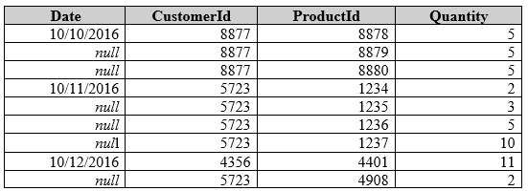

You need to ensure that the values in the Date column contain a date. Null values must be replaced with the date from the previous row. What should you click on the Transform tab in Query Editor?

1. **Forma**t, and then **Clean**
2. **Date**, and then **Earliest**
3. **Fill**, and then **Down**
4. **Replace Values**, and then **Replace Errors**

# Correct Answer: C

# QUESTION 39

Your organization has a Microsoft Office 365 subscription.

When the users attempt to access the Power BI Service, they receive the error message shown in the exhibit. (Click the **Exhibit** button.)



You need to ensure that all the users can access the Power BI service. What should you do first?

1. From the Microsoft Azure Active Directory admin center, assign a Power BI (free) license to each user.
2. From the Power BI Admin portal, modify the Tenant settings.
3. From Microsoft Azure PowerShell, run the Set-MsolCompanySettings cmdlet.
4. From the properties of each dashboard, modify the Share dashboard settings.

# Correct Answer: C

# QUESTION 40

You have a sales report in an app workspace. The report displays a map of sales by location and a bar chart of sales by year. The report has a slicer to filter the data by year.

You need to create a dashboard that contains visualizations. The solution must ensure that you can use the slicer to filter the data by year. What should you do?

1. Pin each visualization to the dashboard, and then add a web content tile.
2. Add a page level filter, and then pin each visualization to the dashboard.
3. Publish the app workspace.
4. Pin the report as a live page.

# Correct Answer: D